

Quality Update

The Official Newsletter of Bovey Tracey Town Council – Issue 47 – July 2014
Bovey Tracey Town Council – 01626 834217 – Bovey Tracey Website - www.boveytracey.gov.uk

Riverside Surgery Befrienders

We are the local voluntary organisation that provides patient transport to the Riverside Surgery and also for outpatient appointments at our local hospitals. We aim to help those who would otherwise have great difficulty in getting to their appointments, often due to age, infirmity, etc. Last year we put out an appeal for more volunteer drivers, and our thanks to those who came forward. However, we still need more! If you are a car owner/driver, living within a 6-mile radius of Bovey Tracey, and you can spare some time during the week, we’d love to hear from you. For further details please contact me on 01626 832850, or email me at jwwj.ferguson@tiscali.co.uk

Jim Ferguson, Chairman

Town Councillors Contact Numbers

Town Mayor - Cllr Eoghan Kelly 830369
Deputy Mayor – Cllr Ulli Arnold 833376

Bovey Councillors:
Tony Allen 836239
Bob Ashby 832388
Doreen Black 07463 495377
Robert Bray 835591
Martyn Evans 830347
George Gribble */** 832764
Anna Klinkenberg* 834328
Steven Leigh 07792 016120
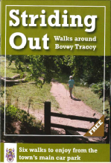
Avril Kerswell* 832923
Tina Richardson 835363
Mark Tregoning 835193
Heathfield Councillors:
David Elphick 832125
Eoghan Kelly 830369
*District Councillor ** County Councillor
Town Clerk - Terry Westwood 834217

Art Exhibition

The Bovey Tracey Society of Artists is holding its annual summer exhibition as “Carnival Gallery” this year, during Bovey Tracey Carnival Week at The Youth Cafe, Fore Street, Bovey Tracey from Sunday 27th July until Saturday 2nd August 2014. The exhibition will be open from 10:00am to 5.30pm from Sunday to Friday and 10:00am to 8:00pm on the final Saturday.

A wide range of work by local artists will be on display for sale, including sketches, watercolours, pastels, acrylics and oil paintings.
Visitors to the exhibition will be able to enter a raffle to win an original framed painting.
Members of the society will be on hand as stewards to help anyone seeking more information about the society, or wanting to become members.

Town Clerk to Retire

Terry Westwood, our Town Clerk, is retiring after more than 12 years as clerk to Bovey Tracey Town Council and next month is getting married to the Archdeacon of Wells, the Venerable Nicola Sullivan.

Terry, who is taking early retirement will be leaving the council at the end of October and moving to Wells. ‘I will miss the wonderful community here because I am passionate about Bovey Tracey and always will be’.

The Town Council is now taking the necessary actions to prepare to advertise the vacancy. Details of the vacancy, when available, will be advertised through various local newspapers as well as on the Town Council’s website, www.boveytracey.gov.uk

Bovey Tracey Information Centre

Are you looking for publicity for a local event? Hundreds of visitors a week visit the Information Centre in Station Road.

So why not publicise your event here?

Call Anne Crosby on 01626 835524 for further details.

Striding Out
Striding Out is a new free booklet available from the Information Centre in Station Road car park, which gives details of six circular walks. All the walks begin and end at the Information Centre and provide a variety of walks through shady woodland and riverside paths.

The booklet has been produced by the Town Council and the Information Centre. Do not delay; pick up your free copy from the Information Centre. Call 01626 832047 to check the opening times. The centre also provides a single point of contact for residents to access a variety of information relevant to Bovey Tracey and the surrounding area.

Tour of Britain 2014

The Tour of Britain will again be visiting Bovey Tracey at some point on Sage 5 of the event from Exmouth to Exeter on 11th September 2014.

The route through Bovey is via Le Molay-Littry Way, Fore Street, Station Road and onwards to Haytor. For further information please visit www.devontourofbritain.co.uk

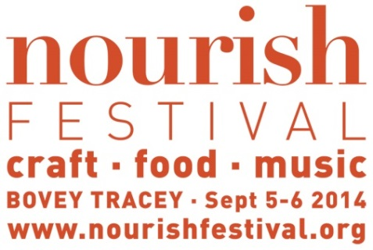

The Nourish Festival is a new event celebrating the very best in regional food, craft and classical. Set in the heart of Bovey Tracey, Nourish is a weekend of events designed to feed the body, the mind and the senses. Nourish Festival is a community initiative led by The Contemporary Craft Festival, The Devon Guild of Craftsmen and the award winning, Cheese Shed.

Building upon the success of The Contemporary Craft Festival, the focus for Nourish will be on quality, regional food and craft businesses and exceptional classical music.

The Nourish food fair will fill Bovey's Fore Street on Saturday September 6th with some of the region's best producers and delicious street food. Ashburton Cookery School will present an inspirational Cookery Theatre in the Methodist Church with some of Devon’s finest chefs. The Great Bovey Bake Off and Junior Bovey Bake Off offer opportunities to get the community reaching for their mixing bowls.
A mini Craft Fair will be hosted in the Town Hall on Saturday September 6th at the top of Fore Street. Curated by Craft Festival Director, Sarah James, The Nourish Craft Fair will showcase a sample of the top quality makers that can be found in the South West. Other events will take place at The Devon Guild of Craftsmen's Riverside Mill.

Ian Wellens from The Cheese Shed, not only knows a shed load about cheese but he was a lecturer in music at Dartington for over 20 years and he has put together an inspiring musical programme. Internationally renowned Brodsky Quartet, will top the bill on Saturday evening with Devon Baroque making a welcome return to Bovey Tracey on Friday evening. Malleticious, a young percussion duo from Totnes will perform an uplifting lunchtime concert on Saturday September 6th.

The Nourish Food & Craft Fair is free, concerts will be ticketed and full details, venues and ticket information can be found via www.nourishfestival.org, telephone 01626 830612 or email: hello@nourishfestival.org



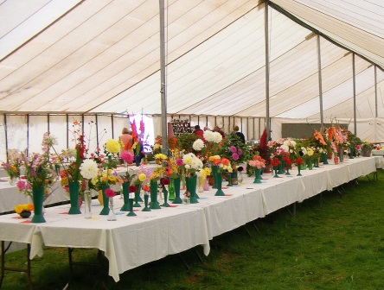
St. Catherines C of E Nursery and Primary School in Heathfield is a forward thinking and progressive school that according to Ofsted is ‘good with outstanding features’, (November 2011).
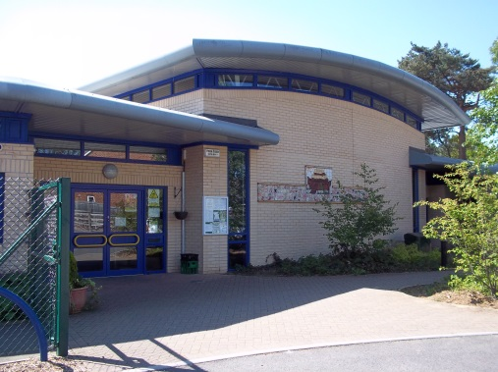

Almost four full years of federated working with St. Michaels C of E Nursery and Primary School in Kingsteignton, (‘outstanding school’ – Ofsted November 2011), has taken the United Schools Federation (USF) to a position of strength on which we can all aim to build together. The federation has now been strengthened with the inclusion of two other schools, St. Mary’s in Brixton, near Plymouth and Marldon Primary School.

There are opportunities for collaborative working between all schools (including parallel learning, joint trips and residentials, linked clubs such as mountain biking, engineering, caving, climbing and scuba diving).
- It is an exciting place to be!
- Outstanding Foundation Stage provision (Ofsted 2011).
- An ‘Early Birds’ club for parents who need to drop off early.
- Exciting curriculum for the 21st century – the International Primary Curriculum (IPC). Used in many countries of the world making it relevant to children and preparing them for a future in an increasingly global society.
- A school counsellor to help children and families.
- Excellent links with the local churches and community.
- We have places in many year groups. Anyone interested in coming for a look around is more than welcome.

Contact the school office to make an appointment or to find out more.
St Catherines C of E Primary School,
Musket Road, Heathfield, TQ12 6SB.
Telephone: 01626 832665 Fax: 01626 834232
admin@stcatherines-heathfield.devon.sch.uk www.stcatherines-heathfield.devon.sch.uk

Bovey Tracey Summer Show

The annual Summer Show, hosted by the Bovey Tracey Horticultural Society, will be held on Saturday 16th August in Parke View Meadow (situated by the bridge at the lower end of Fore Street).

The Show Schedule (still only £1.50) and an Entry Form (entry is 20p per class and free to children and teenagers) can be obtained from The Cottage Tea Shop or Simply Flowers in Fore Street, from the Brimley Post Office, from the Show Manager, John Tibbs (phone 01626 832881) or from me (Marion Edwards, 832811). With only a few exceptions, the classes are open to all. Please drop off your completed entry forms and entry fees at The Cottage Tea Shop or Church Steps, Bradley Road (by the Parish Church) by noon on Wednesday13th August at the latest.

Gates will open at 1.30 pm and the marquee at 2.00. In addition to the exhibits in the main marquee the dog agility demonstration will be back by popular demand, there will be a bird of prey display and Jeremy Leach will share his pottery expertise. There will be plant stalls and, of course, tea, cake and ice cream.
Fingers crossed for a fair day!
Marion Edwards (Show Secretary)

The Friends of Teignbridge Citizens Advice Bureau

Do you like the work we do; giving free, impartial advice to the people of
Teignbridge? Are you able to give an hour or two, once a month? If so, why not consider joining our new "Friends Group"?

The Bureau has to work hard to raise the money needed to provide free advice. This is especially difficult at the moment due to increased demand for its services and reduced government help. We are looking for a group of people who can help us raise money by organising events & manning stalls.

For more information please look at our website http://www.teignbridgecab.org.uk/friends-group/ or email: friends@teignbridgecab.org.uk.

Bovey Tracey Town Council Meetings

Starting time 7.00pm
Public Speaking Period at the start of each meeting
22nd September2014
17th November 2014

Town Hall - Bovey Tracey

Bovey Tracey Flag Festival

The aim of the project with the support of the Town Council is to decorate Fore Street and Station Road with large fabulous colourful flags with the focus being the Nourish Festival in September.

All the flags will be unique bespoke designs similar to those recently flying in Moretonhampstead. They will be made with the Businesses and Organisations that sign up to the project and with the Lead Artist, Bridget Arnold’s help and guidance. This time we have 19 Organisations signed up to take part, but don’t worry it is just the start of the project with more opportunities to have a flag for next year as well.

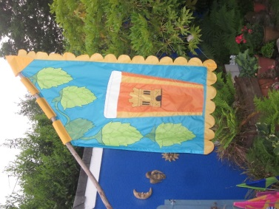
There have been 12 day workshops in the Town Hall where local businesses and community groups have come together to work with Bridget to design their flags, then to start the making process of cutting and sewing the pieces of rip stop material together.
When the flags are all completed they will be hung on 3 metre long poles coppiced from a local wood and stripped of its bark. These are supported by pole holders made by a local blacksmith that will be installed on the buildings towards the end of July. For further information please contact Bridget Arnold on: bridgetarnold66@gmail.com or 01626 833130

