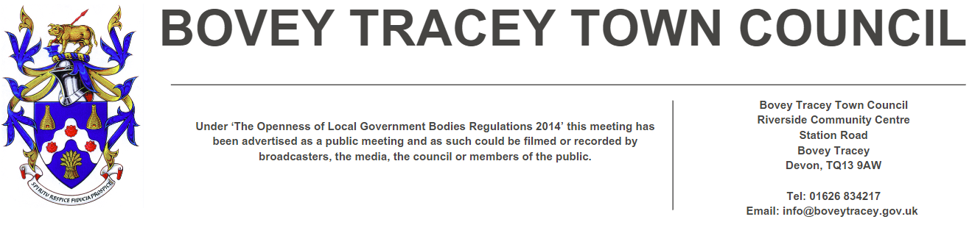
20th October 2026

To: Members of the Finance, Resources & General Purposes Committee

Cllrs Brooke (Ex Officio), Allen, Burton, Kennedy, Oldrieve, Simmons and West.

Cc: All other Members of the Council for information.

Dear Councillor,

You are hereby summoned to attend a meeting of the Finance, Resources and General Purposes (FR&GP) Committee on Monday 26th October 2026 at 7.00 pm at the Riverside Community Centre for the purpose of transacting the business as set out on the agenda below.

AGENDA

FR&GP.26/79 Apologies for absence:
To receive and consider for acceptance, apologies for inability to attend.

FR&GP.26/80 Declarations of Interest and Requests for Dispensations
To declare any disclosable pecuniary interests or any other interest which members may have in the following agenda items and consider any dispensation requests.

**Public Participation:
We welcome the public to attend meetings and invite comments or questions regarding any of the agenda items. The Committee, at the Chairperson’s discretion, sets aside a short period of time for this at the commencement of the meeting.

FR&GP.26/81 Minutes:
i) To agree as a correct record and approve the minutes of the meeting of 1st September 2026 (*copy enclosed).
ii) To receive any update(s) on actions/items from the previous meeting.

FR&GP.26/82 Standing Item – Climate and Ecology Emergencies:
To note the Council Declaration and to embed the climate and ecology emergency declaration across all Council services, activities, plans and other relevant work, considering the environmental impact of decisions, ensuring a fully integrated approach to mitigating the impact of climate change.

FR&GP.26/83 Accounts & Financial Statement:
To receive and approve:

i) Payment and receipt transactions between 25th August 2026 and 14th October 2026 (*copy enclosed).
ii) Bank reconciliation as at 14th October 2026 (*copy enclosed).
iii) note the balances and borrowing as below:

General Account: £ 27,390.07 (as at 14.10.26)
Income/Precept A/C: £ 333,417.91 (as at 14.10.26)
Capital A/C: £ 18,317.36 (as at 14.10.26)
CIL A/C: £ 49,806.72 (as at 14.10.26)
CCTV Grant: £ 10,016.43 (as at 14.10.26)
Redwood Bank (Rev) £ 85,000.00 (as at 14.10.26)
Charity Bank Invest (Rev) £ 85,000.00 (as at 14.10.26)
Cambridge & Counties (CiL) £ 130,000.00 (as at 14.10.26)
Nationwide Build Soc (CiL) £ 130,000.00 (as at 14.10.26)
B’hamshire Build Soc (Cap) £ 110,000.00 (as at 14.10.26)
Hampshire Trust Bank (CiL) £ 130,000.00 (as at 14.10.26)

Borrowing
Public Sector Works Loan £ - 319,348.30 (as at 05.10.26)

FR&GP.26/84 Capital Programme & Infrastructure Delivery Plan (IDP) (standing item):
To review the current Programme and Plan and approve amendments if/as appropriate:
- Capital Programme (*copy enclosed)
- Infrastructure Delivery Plan (*copy enclosed)

FR&GP.26/85 2026/27 Budget Monitoring – Quarter 2:
To receive and note the Town Council’s Quarter 2 budget monitoring statement (*copy enclosed).

FR&GP.26/86 Town Council Insurance Cover – Renewal due 1st November 2026:
To receive a report on behalf of the Finance Officer and to consider the recommendations within (*copy to be circulated).

FR&GP.26/87 Community Infrastructure Levy (CiL) Groups Policy – Grant Application(s):
To receive and a consider grant applications for CiL on behalf of:
- Bovey Tracey Swimming Pool for £25,000 (*copy enclosed).
- Bovey Tracey Athletic Football Club for £20,834.70 (*copy enclosed).

FR&GP.26/88 Interim Audit/Internal Auditor:
i) To receive and consider the recommendations and subsequent actions highlighted within the audit report (*copy to be circulated).
ii) To review the internal auditor’s confirmation of independence from the Council’s day-to-day operations and the competence and qualifications of audit staff, and to confirm that the arrangements in place are appropriate.

FR&GP.26/89 Maturity of Investments:
To consider approving the delegation of authority to the Town Clerk/RFO to arrange reinvestments with existing banking institutions, in accordance with the Council's Treasury and Investment Policy.

A report detailing the reinvestments undertaken will be presented to the Committee on 4th January 2027, together with a review of investment risks, including the Council's eligibility for protection under the Financial Services Compensation Scheme (FSCS).

FR&GP.26/90 Emergency Expenditure – Riverbank Erosion Repairs:
To retrospectively note emergency expenditure of £1,500 incurred by the Town Clerk/RFO for urgent riverbank erosion repairs, in accordance with Financial Regulation 5.18 and to approve funding form the Town Council’s contingency budget.

FR&GP.26/91 Document Retention Policy:
To review and consider re-adopting:
i) Document Retention Policy (*copy enclosed)
ii) List of documents for retention/disposal (*copy enclosed)

FR&GP.26/92 Matters brought forward by Councillors: (for information only).
- Authorisation of banking transactions (Town Clerk).


SIGNED DATE: 20th October 2026
M WELLS - TOWN CLERK

*Copies of correspondence circulated to Councillors with this agenda, which will be considered at the meeting.

